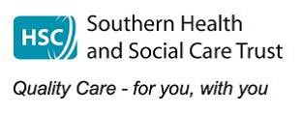

GP Referral Guidance Sheet Southern Trust Adult Eating Disorder Service

All referrals must be made through the Mental Health Booking Centre-If you require Eating disorder and another service eg PMHC please clearly indicate both services on referral. In order to adequately process a referral in timely manner, and to ensure that urgent cases are picked up quickly the following information must be provided at referral. If information is not provided, referrals will be returned/rejected. This service is only commissioned to treat Anorexia, Bulimia and OSFED

**Types of Eating Disorder**

Summary guides to types of eating disorders are available on

[Types of Eating Disorder (beateatingdisorders.org.uk)](https://www.beateatingdisorders.org.uk/get-information-and-support/about-eating-disorders/types/)

We do not treat

Binge Eating Disorder

ARFID/PICA/Rumination Disorder

Urgent patients will be contacted and offered an appointment within 5 working days. Priorities will be offered an appointment usually within 3 weeks. If the patient fails to attend or does not wish to avail of assessment care will fall back to the care of GP. **Medical responsibility and treatment of any symptoms sits with GP until the patient has been assessed by the Eating Disorder Service.**

**Urgent/Priority**

BMI <15

Rapid weight loss of >1kg/week for 2 weeks in an undernourished pt.

Rapid weight loss at any weight.

Biochemical abnormalities

Diabetes/Pregnancy

**Physical Assessment**

Current weight/height BMI-Checked or self reported?

Rate of weight loss if known?

Bloods- FBC, U+E,LFT, Mg, Glucose, TFT, Bone Profile.(within past 4 weeks)

If BMI < 15 bloods within last week.

BMI <15 or evidence of hypokalemia, ECG and baseline obs are recommended

**Eating Disorder History**

These questions can be cut and pasted into referral and answered or used as a guide

***What is the patient reporting in terms of concerns about weight and shape?***

***Are they actively engaging in behaviours to influence weight and shape****?* What are these behaviours- eg vomiting, laxatives, exercise, diuretics, weight loss medications/injections. How often/How much?

***Is there a fear of weight gain or deliberate attempts to control weight?*** Please describe

***Has the patient consented to referral?***

WE DO NOT TREAT BINGE EATING DISORDER

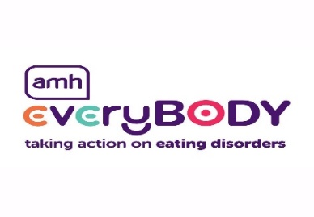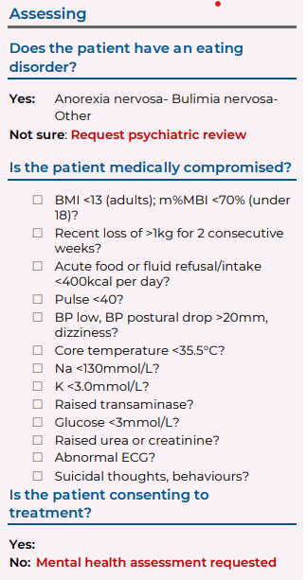

If you wish to discuss a potential referral or are worried about an urgent case please telephone us on 02837561936. A member of the team will be happy to discuss with you.

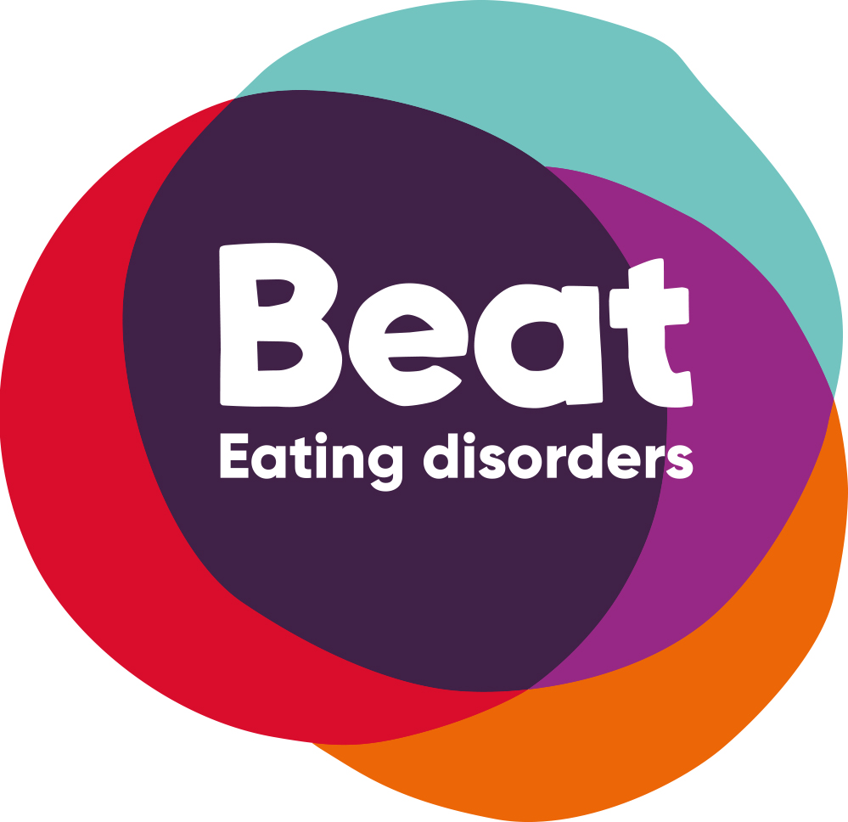Beat is the UK eating disorder charity. It has a vast amount of information and supports for sufferers, carers and professionals. Beat offers many online support forums and educational material and is available to people from Northern Ireland

[www.beatingeatingdisroders.org.uk](http://www.beatingeatingdisroders.org.uk)

**The SCOFF questionnaire**

SCOFF helps identify a potential eating disorder. A score of 2 or more positive responses to the following questions would indicate that a fuller assessment for eating disorder is required. SCOFF Questions

• Do you ever make yourself **S**ick because you feel uncomfortably full?

• Do you worry you have lost **C**ontrol over how much you eat?

• Have you recently lost more than **O**ne stone in a three month period?

• Do you believe yourself to be **F**at when others say you are too thin?

• Would you say that **F**ood dominates your life?

However, some people with anorexia nervosa will deny even these behaviours and it is important to keep weight under review if an eating disorder is suspected.

**Action Mental Health –everyBODY (Portadown)**

Is our local voluntary services partner, everyBODY can provide support and guidance to someone with an eating disorder waiting to be seen or if they need continued support after discharge from our service. everyBODY offers carers support and provides support to people with Binge Eating Disorder.

Phone 02838392314

Email:dmcready@amh.org.uk

www.amh.org

Link to Royal college of Psychiatry Report **Medical Emergencies in Eating Disorders is attached.**

[*college-report-cr233-medical-emergencies-in-eating-disorders-(meed)-guidance.pdf (rcpsych.ac.uk)](https://www.rcpsych.ac.uk/docs/default-source/improving-care/better-mh-policy/college-reports/college-report-cr233-medical-emergencies-in-eating-disorders-(meed)-guidance.pdf)

This report provides clear guidance and alerts for those assessing/treating anyone with eating disorders. Pages 31-34 are particularly useful for risk assessment