**REGIONAL ADULT SAFEGUARDING PROCEDURE**

**APP1 ADULT AT RISK OF HARM CONCERN**

**For completion by all organisations required to have an Adult Safeguarding Champion**

*PLEASE ENSURE SECTIONS 1 & 2 ARE FULLY COMPLETED FOR ALL CONCERNS*

|  |  |  |
| --- | --- | --- |
| **Name:** | **Date of Birth:**  *(if not known, please give approx age)* | **Date of Referral:** |
| **Address:**  **Postcode:** | **Gender:** M  F  Other  **Ethnicity:** | **Service/Client Group:** |
| **Telephone No:** | **Is this person known to the Trust?**  Yes  No  Don’t Know | **H&C / Reference No:** |

**SECTION ONE**

***Section 1 – completed by person reporting the concern***

|  |  |  |  |  |
| --- | --- | --- | --- | --- |
| **Details of Person reporting the concern** *(person bringing the concern to your agency’s attention)* | | | | |
| **Name:** | | **Relationship to adult at risk of harm:** | | |
| **Job title and agency:** | | **Contact Number:** | | |
| **Who was the first person to note the concern** | | | | |
| **Name:** | **Relationship to adult at risk of harm:** | | **Contact**  **number:** | **Date:** |

|  |  |  |  |  |  |  |
| --- | --- | --- | --- | --- | --- | --- |
| **Source/Origin of Concern** | | | | | | |
| **GP** | **Housing Provider** | | **Learning Disability Hospital** | | **Regulated Care Home** | |
| **RQIA** | **MARAC** | | **Adult Mental Health Hospital** | | **Supported Living** | |
| **PSNI** | **Day Care** | | **Acute General Hospital** | | **Self** | |
| **Prison** | **Homecare Worker** | | **Non Acute Hospital** | | **Carer** | |
| **Benefits Branch** | **RESW** | | **Other Trust** | | **Anonymous** | |
| **Vol. Organisation** |  | |  | | **Other** *Specify* | |
| **Location of incident** | | | | | | |
| **Day Care** | | **Own Home** | | **Public Place** | | **Adult placement** |
| **Nursing Home** | | **Residential home** | | **Supported living** | | **Adult Hostel** |
| **Non acute hospital** | | **Acute general hospital** | | **Mental Health Hospital** | | **Learning Disability Hospital** |
| **Prison** | | **Short Break** | | **Other** *specify* | | |

|  |  |  |  |  |  |  |  |
| --- | --- | --- | --- | --- | --- | --- | --- |
| **Key Contacts** | | | | | | | |
|  | **Name** | | **Address** | | **Contact number** | | |
| **Key Worker** |  | |  | |  | | |
| **Care Manager** |  | |  | |  | | |
| **G.P.** |  | |  | |  | | |
| **Family/Carer** |  | |  | |  | | |
| **Significant other** |  | |  | |  | | |
| **Other** |  | |  | |  | | |
| **What is the PRIMARY form of suspected, admitted or known harm or abuse? *(tick one only)*** | | | | | | | |
| Physical | | Sexual (Incl. violence) | | Psychological | Neglect | | |
| Financial | | Exploitation | | Institutional |  | | |
| **Does the PRIMARY form of alleged harm or abuse also relate to the following definitions?** | | | | | | | |
| Domestic & sexual violence | | Hate crime | | Modern slavery/Human Trafficking | | | |
| **INCIDENT REPORT** | | | | | | | |
| **Background information**  ***Home circumstances*** | | | | | | | |
| Does the adult at risk of harm live alone? | | | | | | Yes | No |
| Does the person who is suspected to have caused harm live with the adult at risk of harm? | | | | | | Yes | No |
| Is the adult at risk of harm present location different from home address? | | | | | | Yes | No |
| If *Yes* give present location  Provide details of the supports available to the adult at risk of harm  ***Factors precipitating incident***    ***Issues of capacity and communication needs of adult at risk*** | | | | | | | |
| **Incident Report – Location/Date/ Time** *(please give exact details of what has been reported and if appropriate include names of any witnesses and note injuries on APP1 body chart).* | | | | | | | |
| **Details of any witnesses:**   1. **Name:**   **Address:**  **Contact No:**     1. **Name:**   **Address:**  **Contact No:** | | | | | | | |
| **Describe the impact of the incident on the adult at risk of harm:** | | | | | | | |

|  |  |  |  |
| --- | --- | --- | --- |
| **Adult At Risk of Harm’s Knowledge Of Referral** | | | |
| **Does the adult at risk of harm know that a referral may be made?**  **Is the adult at risk of harm able to give informed consent?**  **Has the adult at risk of harm consented to a referral?** | **Yes**  **Yes**  **Yes** | **No**  **No**  **No** | **N/K** |
| **If no please give details:**  **Record adult at risk of harm or carer’s views regarding reporting to PSNI** | | | |

|  |  |  |
| --- | --- | --- |
| **Have You Taken Any Emergency Action to Avoid Immediate Serious Risk?** | | |
| **Was immediate protection needed for adult at risk of harm?**  *If Yes give details:* | **Yes** | **No** |
| **Are there any children or other adults at risk?**  *If Yes give details:* | **Yes** | **No** |
| **Was immediate protection required?**  *If Yes give details:*    **Is there a need for a DASH to be completed? Yes No N/K** | **Yes** | **No** |

|  |  |  |
| --- | --- | --- |
| **Details of Person/Persons Suspected of Causing Harm** | | |
| **Name:** | **Date of Birth:** | **M  F** |
| **Address:** | | |
| **Is the person(s) suspected of causing harm aware an allegation has been made against them?**  **Yes No N/K** | | |
| **Is the person(s) suspected of causing harm known to the adult at risk of harm? Yes No N/K**  ***If yes please specify below:***  **Family member Another service user Paid carer Trust employee Other**  *(specify)* | | |
| **Provide any known information about the capacity of the person alleged to have caused the harm.** | | |

|  |  |
| --- | --- |
| **Any Additional Information Relevant to the Report**  *(Please note the views of others you have consulted and note any difference of opinion)* | |
|  | |
| **Signature**  **Print** | **Date** |

**SECTION 2 RECORD OF DECISION MAKING**

***TO BE COMPLETED BY ASC/APPOINTED PERSON/LINE MANAGER***

|  |  |
| --- | --- |
| **Have previous APP1s or DASH assessments/concerns being recorded? Yes No N/K**  ***If yes give summary of previous APP1s / DASH*** | |
| **ACTIONS AGREED**  **Advice/guidance required from HSC Trust staff**  **OR Adult Protection Gateway Service**  **Is further information required to inform the outcome of the decision below?** **Yes** **No**  **If yes, what information is required, who will action by when? (The referrer and relevant line manager/appointed person/ASC retains responsibility, where possible, until this information is received. If further information is required by the Trust and the referrer is an external agency the ASC will forward the APP1 section 1 and Section 2 at this point to the named Trust Keyworker for final completion of section 2)**    **OUTCOMES** (Tick one of the following)   1. **Adult in need of protection-**   **Refer to Trust Adult Protection Gateway service** **Yes** **No**   1. **Adult at risk of harm – manage through alternative safeguarding response** **Yes** **No**   Select relevant alternative safeguarding response(s):  Referral to core HSC service  Referral to regulator  Referral for internal quality improvement action  Referral to other statutory agency  Referral to C&V support/advise  Referral to other process (complaints; HR; disciplinary; SAI review)   1. **Inappropriate adult safeguarding referral** **Yes** **No** | |
| **Provide rationale for outcome selected** | |
| *This should prioritise issues of risk/harm/possible criminal offence/human rights consideration* | |
| **Under service regulation or contract is there a need to also refer to or notify?** | |
| Professional Community Assessment  Quality Assurance Team  Care Management  Contracts  Human Resources  Adverse incident reporting  RQIA  PSNI  BSO Counter Fraud & Probity Services | |
| **Signature**  **Print**  Line Manager/Appointed person/ASC  Forwarded to:  *Please note responsibility for the adult’s immediate safety remains with the referrer until actions are agreed with the DAPO* | **Date**  **Date** |

**APP1 – ADULT IN NEED OF PROTECTION REFERRAL**

**SECTION THREE**

Initial screening to be completed by Trust Adult Protection Service

|  |  |  |  |  |  |
| --- | --- | --- | --- | --- | --- |
| Is immediate action required to protect the adult in need of protection? | Yes | No | | | |
| Urgent medical attention required?  Additional care resources or staff required?  Protection or respite admission required?  Any other action required? | Yes  Yes  Yes  Yes | No  No  No  No | | | |
| **Details of Decision Making** |  |  | | | |
| Is there a possible criminal offence? | Yes | No | | | N/K |
| Is there a need to preserve possible forensic evidence? | Yes | No | | | |
| Is there a need for immediate report to the PSNI? | Yes | No | | | |
| Is Joint Agency Consultation required?  Yes  No  Pending more information  *If Yes, please complete AJP1* | | | | | |
| **ARE THE CRITERIA MET FOR NOT REPORTING TO PSNI?** | | | **Yes** | **No** | |
| ***In making the decision NOT to report to PSNI please ensure ALL criteria have been met.***  The person has capacity to make an informed decision and does not want to make a complaint to PSNI/ or the person does not have sufficient (Refer to Joint Protocol Appendix 7 Consent/Capacity/Human Rights)  And  The Trust is not required by law to make a referral to PSNI  If the incident does not meet the threshold of relevant offence under section 5 of the Criminal Law Act (NI) 1967 *(Refer to Joint Protocol Appendix 2 Definition of Relevant Offence)*  And  It is a minor incident  A comprehensive assessment of all the factors must be taken into consideration  *(Refer to Joint Protocol Appendix 8 Factors to be considered in the assessment of the seriousness of Harm and Risk of Harm)*  And  The situation is being managed through an Adult Protection process and/or there are other protective measures in place | | | | | |
|  | | | | | |

|  |  |  |  |
| --- | --- | --- | --- |
| **Are there any Human Rights Issues?**  *If yes please give details:* | Yes | No | N/K |
| **Do the RQIA need to be informed?**  If yes;-  Name of Inspector: | Yes | No | N/K |
| **Does the Trust need legal advice?**  Date of Contact: | Yes | No | N/K |

|  |  |  |  |  |  |  |  |
| --- | --- | --- | --- | --- | --- | --- | --- |
| **Are there any potential DAPO’s / Service Managers to be consulted?**  *If Yes give details of DAPO’s below:* | | | Yes | | No | | N/K |
| Name: | Trust: | Service Area: | | Contact No: | | | |
| Name: | Trust: | Service Area: | | Contact No: | | | |
| Name: | Trust: | Service Area: | | Contact No: | | | |
| **Has a discussion taken place?** | | | | Yes | | No | |
| *If yes record any joint working and feedback arrangements agreed between DAPO’s/Managers*  *(NB: This is critical when there is more than one Service area or one Trust involved).*  *Details of discussion:* | | | | | | | |
| Outcome of initial screening and actions agreed by DAPO under adult protection procedures | | | | | | | |
| Referral forwarded to Trust core team for professional assessment as Adult at Risk of Harm  Tick alternative safeguarding responses:  Escalation to service manager re quality of service provision;  Referral to core HSC service  Referral to regulator  Referral for internal quality improvement action  Referral to other statutory agency  Referral to C&V support/advise  Referral to other process (complaints; HR; disciplinary; SAI review)  Referral accepted for investigation under adult protection procedures  Referral being considered under joint protocol  No further action under adult safeguarding | | | | | | | |

|  |  |  |  |
| --- | --- | --- | --- |
| Consideration when allocating referral? | | | |
| Has the adult in need of protection any preferences relating to who should carry out the investigation? (e.g. gender)  *If yes, please specify* | Yes | No | N/K |
| Has the adult in need of protection any special requirements?  *If yes, please specify* | Yes | No | N/K |
| Are there issues of safety for the worker?  *If yes, state what safeguards are in place* | Yes | No | N/K |
| Has the adult in need of protection been visited/seen?  *If no, state reasons* | Yes | No |  |

|  |  |
| --- | --- |
| Referral forwarded for allocation to: | Date |
| Name of team: | |
| Name of person receiving referral: | |
| Contact No: | |
| Signature of DAPO screening referral: | |



**ADULT PROTECTION PROCEDURES**

**REFERRAL FORM – APP1 (a) BODY MAP**

**Name**:  **Date of birth**: 

**Health & Social Care Number** (*if known)* 

APP1 (a) Body Map is to be used in conjunction with the APP1 Referral form by practitioners to record

the location, size and number of injuries which may have been caused as a result of abuse or inappropriate

care. Where used, the completed APP1 (a) Body Map should be submitted with the APP1 Referral form.

Please mark with numbers drawn on the body map in black ink to indicate the different injuries, and

provide brief details for each injury, e.g. measurements of wound, colour of bruise, etc using arrows

(a ruler is provided to assist with measurement):

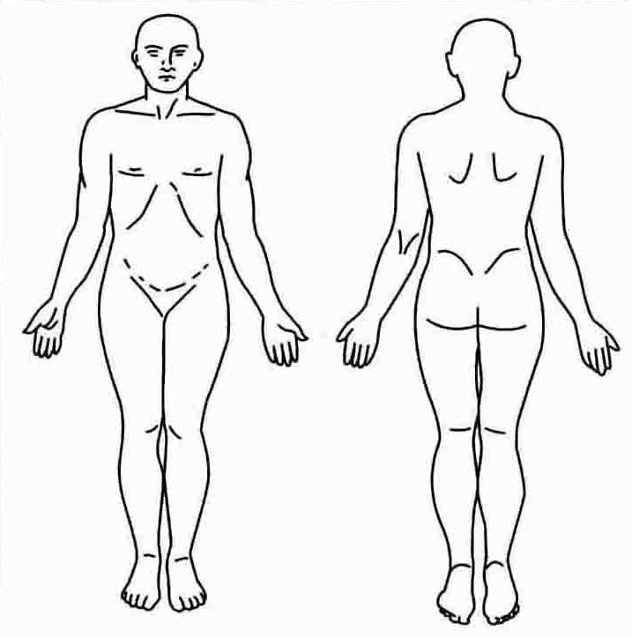

|  |  |  |  |  |  |
| --- | --- | --- | --- | --- | --- |
| **No** | **Site** | **Size** | **Bruise/cut/burn/ pressure ulcer/other** | **Colour / Grade** | **Comments** |
| **1** |  |  |  |  |  |
| **2** |  |  |  |  |  |
| **3** |  |  |  |  |  |
| **4** |  |  |  |  |  |
| **5** |  |  |  |  |  |
| **6** |  |  |  |  |  |

**Body Map notes:**

Note any other details, such as anything the adult at risk discloses on examination

(verbatim), or information received from any other source regarding injuries.



**Front & Side Views – Head**

  

|  |  |  |  |  |  |
| --- | --- | --- | --- | --- | --- |
| **Number** | **Site** | **Size** | **Bruise / cut / burn / pressure ulcer / other** | **Colour / Grade** | **Comments** |
|  |  |  |  |  |  |
|  |  |  |  |  |  |
|  |  |  |  |  |  |

|  |  |
| --- | --- |
| **Timing of Injury:** | |
| **Date when the Injury happened** (*if Known*) |  |
| **Date Injuries above were first observed**  (*if this is different to the original date*) |  |

|  |  |
| --- | --- |
| **Completed By:** | |
| **Printed Name/designation of person completing Body Map form** |  |
| **Signature of personal completing Body Map form** |  |
| **Contact details of person completing Body Map Form** |  |
| **Date/time of completion** |  |
| ***(NB. When used, completed APP1 (a) Body Map form should be attached to completed APP1 Referral form)*** | |